Using the Rocket motor test Stand.

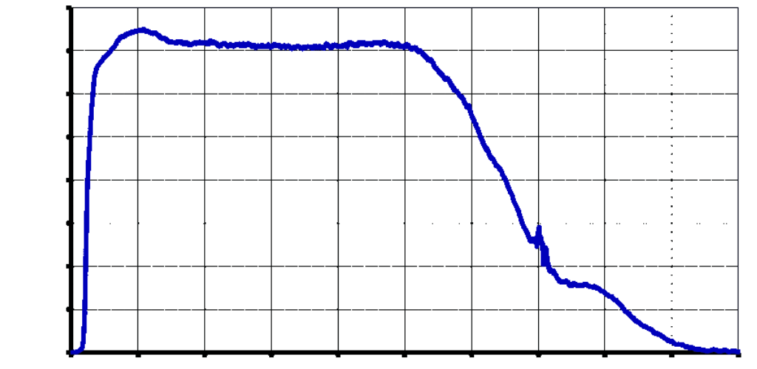

|  |  |  |  |
| --- | --- | --- | --- |
| **Version** | **date** | **Author** | **Comments** |
| 0.1 | 10/11/2021 | Boris du Reau | Initial version |
|  |  |  |  |
|  |  |  |  |

**Rocket Type**

|  |  |  |  |
| --- | --- | --- | --- |
| **Micro-max** | **Model Rocket** | **Mid power** | **High power** |
| yes | yes | yes | yes |

**Category**

|  |  |  |  |
| --- | --- | --- | --- |
| **Construction technic** | **Ground Support** | **Electronic** | **Other** |
|  |  | **X** | X |

Objectives 3

Test stand characteristics 3

Where to find the latest code? 4

How does it work? 4

Step 1 – Building a test stand 5

Step 2 – Building the acquisition board 6

Step 3 – Building the acquisition board firmware 7

Step 4 – In Installing the Android app 8

Step 5 – Flashing the board firmware 8

Step 6– Configure the Bluetooth or 3DR modules 9

Step 7 – Pairing the Bluetooth device 11

Step 8– Configure the test Stand board 11

Step 9– Calibrate the test stand board 11

Step 10 – Configure the test Stand application 12

Step 11 – Connect the test stand with your launch controller 12

Step 12 – Record some thrust curve. 13

Step 13 – Manage thrust Curves 13

Step 14 – Export and use thrust Curves 13

Step 15 - Using the telemetry 15

Step 16 - Board status 15

# Objectives

The following document will explain how to use the Rocket motor test stand, configure it and use the Android software to read and export thrust curves.

At the time of writing this document, the test stand board can be built using an ATMega 328 or an STM32 with an HC break out board. The STM32 board should be a lot faster than the ATMega 328 board.

The test stand can only record thrust they will be an addition to also record pressure in the future.

The application can be installed on pretty much any Android device starting from version 5.x of the Android OS.

The application can be either compiled from source code or can be installed from the Android play store.

# Test stand characteristics

* Use any gauge sensor, it calibrate itself using a known weight
* Trigger recording from your launch controller
* Can record from 10 to 40 measures per second
* Can record up to 25 thrust curves
* Ability to set the recording time
* Telemetry
* Multi languages, so far can do French and English but can be translated in other languages
* Graphical front end using an Android device
* Connect to Android using Bluetooth or 3DR module to do long range telemetry
* Ability to export to a CSV file or a RASP file
* Ability to flash the firmware from your Android device
* Application is available on the Android App store
* On line help for each screen

# Where to find the latest code?

The latest code can be found on github

For the board firmware

<https://github.com/bdureau/MotorTestStand>

For the Android front end

<https://github.com/bdureau/RocketMotorTestStandConsole>

# How does it work?

The test stand currently only measure thrust using a gauge sensor. The analogue signal from the sensor is converted and stored in the test stand board eeprom. Using an Android device you can connect to the test stand board using a Bluetooth module or a 3DR radio module to do long range telemetry.

# Step 1 – Building a test stand

The test stand will need to be strong enough to hold the motor while you are firing it. It will be where you have all your various gauge sensors.

This is an example of a build.

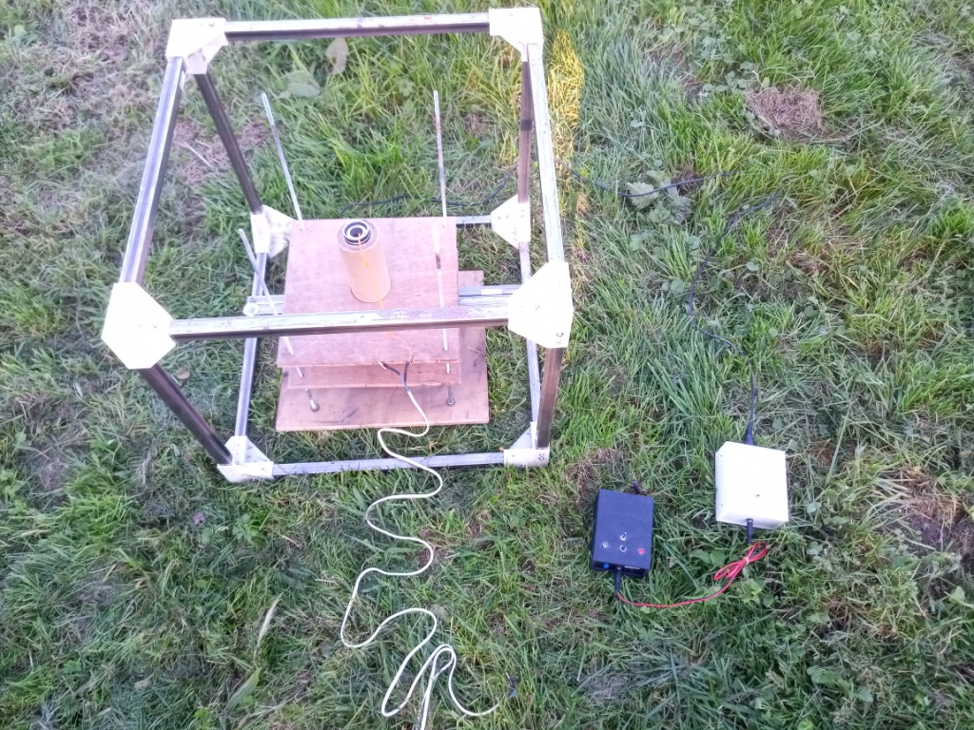

# Step 2 – Building the acquisition board

The acquisition board is pretty simple; it consists of a signal amplifier module and a micro controller.

It also has an entry that can be linked to your launch controller so that it triggers the recording of the motor thrust when the motor is fired.

The schematic look like this

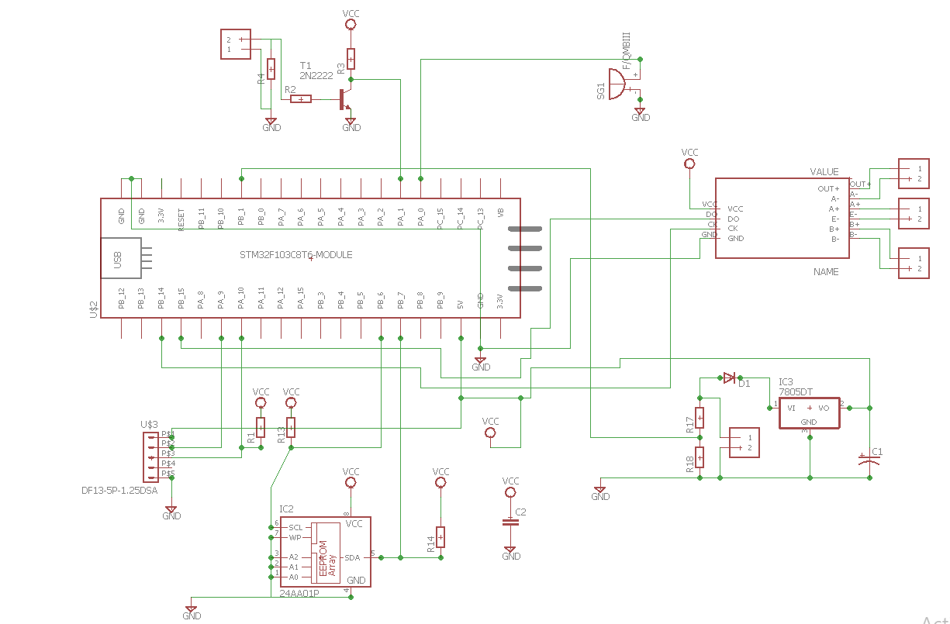

The board PCB looks like the one below. Note that this showing a 3DR module for long range telemetry.

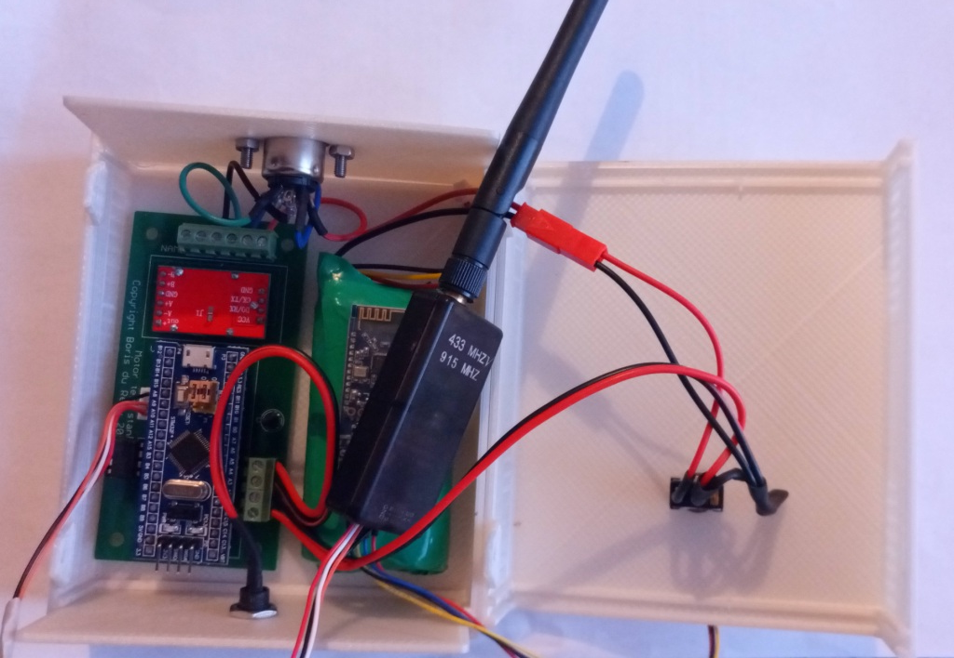

The gauge sensor is attached using a DIN connector. The launch controller is connected to the test stand using a jack.

# Step 3 – Building the acquisition board firmware

The acquisition board firmware has been written using the Arduino environment but if you are not a developer you can flash the board firmware from the Android app using a cable. More on that later.

There are currently 2 options for the firmware, either compile it for an ATMega 328 board or compile it for an STM32F03 board.

Note that the STM32 based board are faster and will allow more measure per second.

# Step 4 – In Installing the Android app

The Android app can be compiled from source our installed from the Android play store. If you want to compile it from source you will need to download and install Android studio on your PC or Mac.

It has a simple main screen from which you can access all functionalities

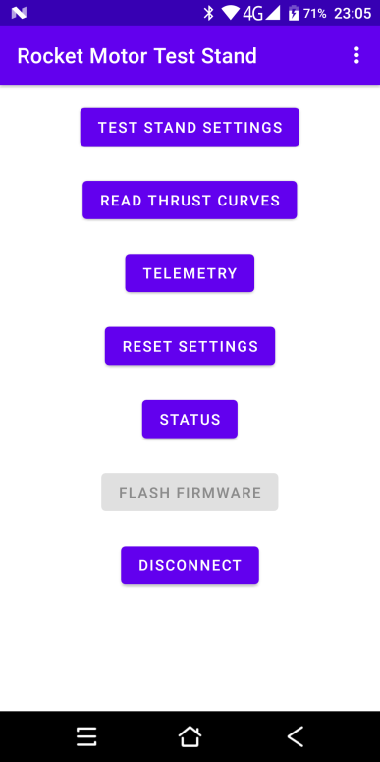

# Step 5 – Flashing the board firmware

Using a ttl cable you can connect the test stand board to your Android device and update the firmware. Just click the flash firmware button, select your board firmware and follow the on line instructions to flash it.

This will insure that the board firmware you are using is compatible with the console application that you are using.

When updating the application from the store please make sure that flash your board firmware.

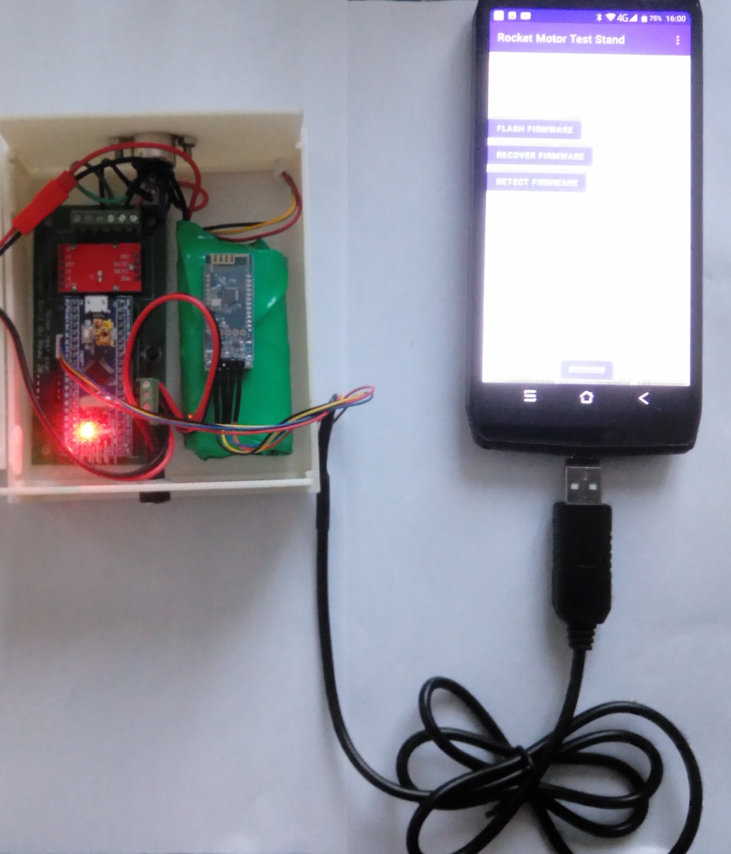

# Step 6– Configure the Bluetooth or 3DR modules

In order to have the Bluetooth or 3DR modules communicating at the same speed as the test stand board you will need to set their speed.

By default the board can communicate at 38400 bauds so that you will have to set the speed of the 3DR and Bluetooth module to 38400 bauds.

This can be done by accessing the configuration in the menu and following the on line instructions.

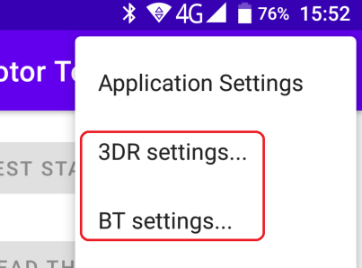

To connect the modules to you phone you will need a ttl cable and micro USB or USB type C adapter.

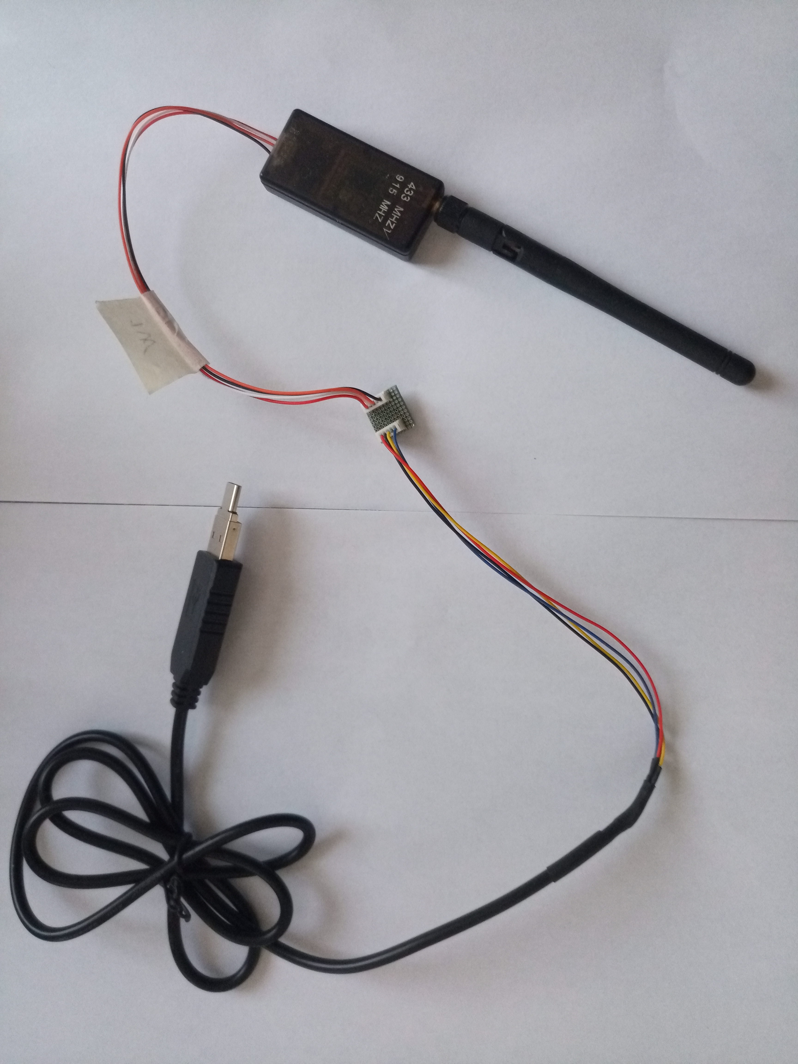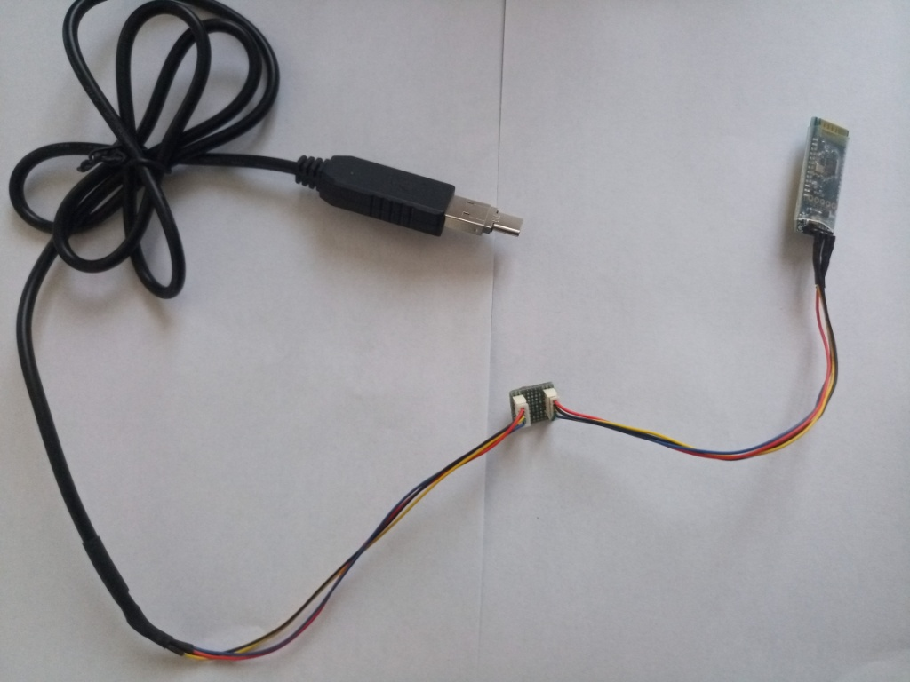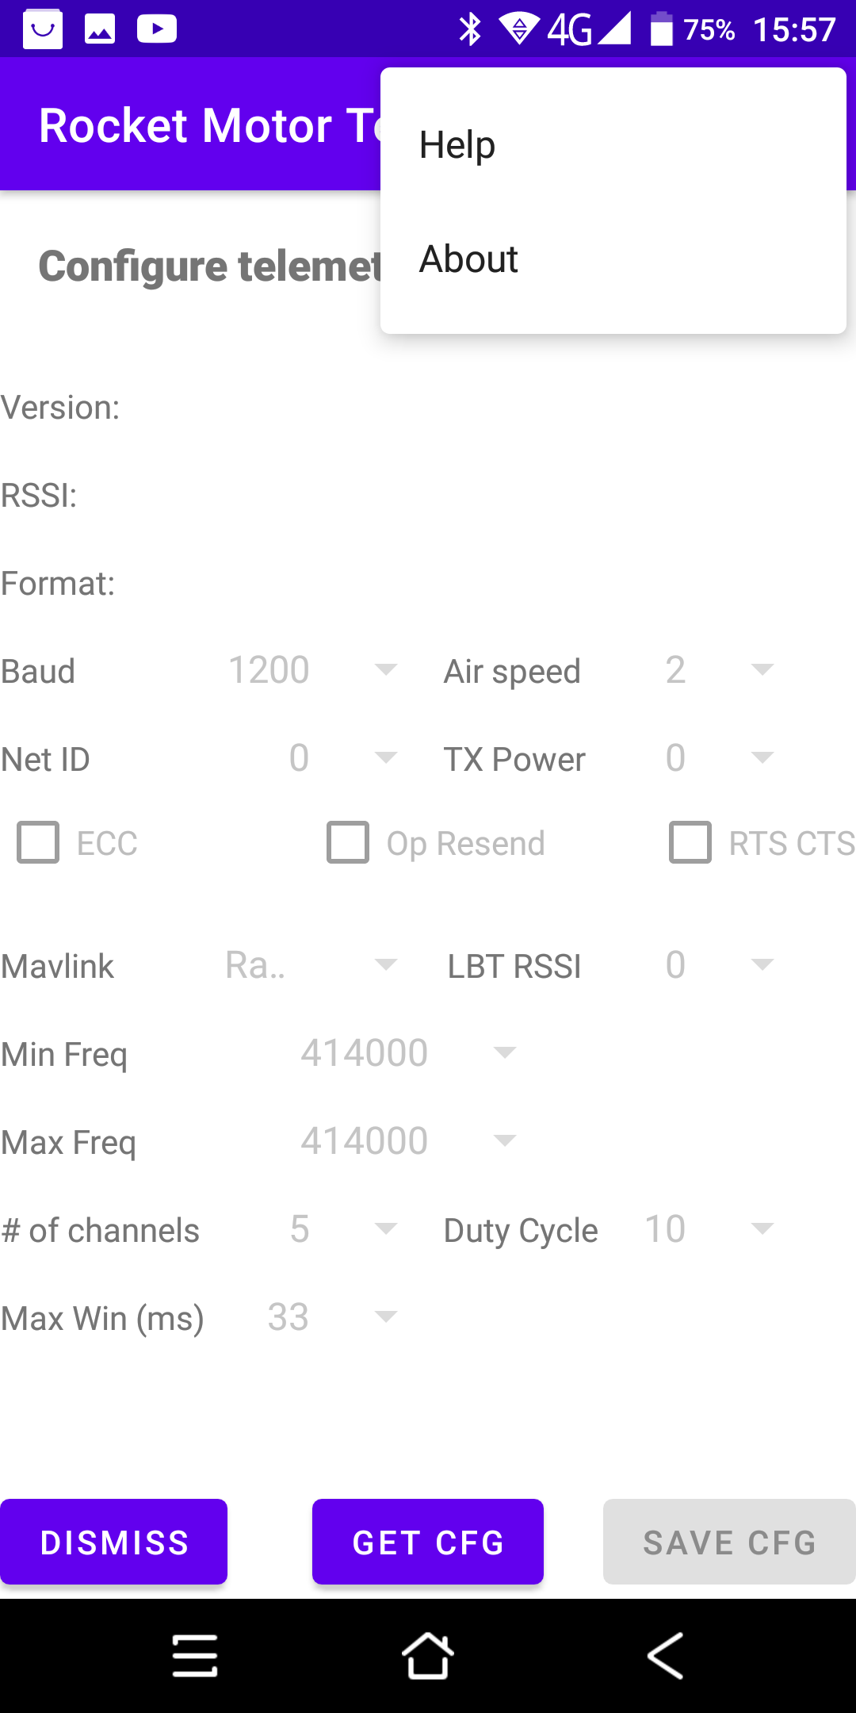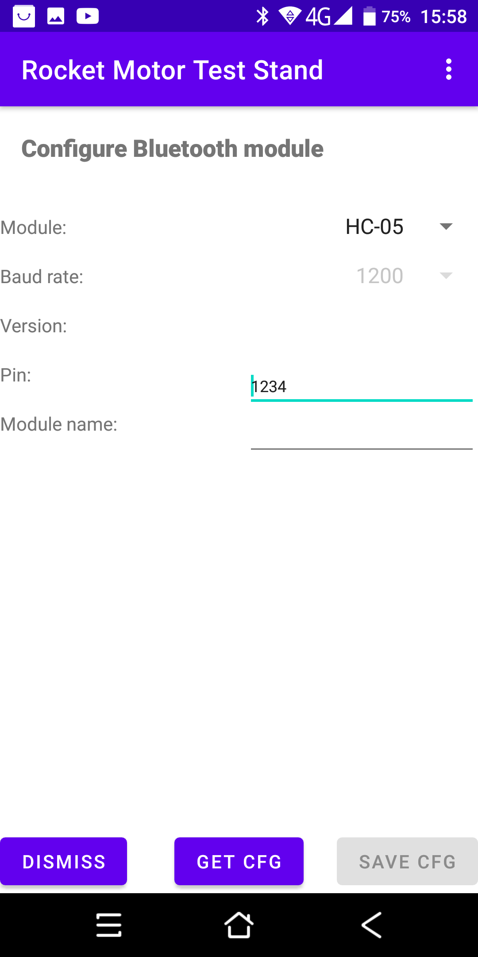

# Step 7 – Pairing the Bluetooth device

You will need to pair the test stand Bluetooth module with your Android device before you can connect to it. First make sure that your module has been setup to communicate at 38400 baud (You can configure the Bluetooth module using the app refer to previous step).

The module name used by the test Stand could be HC05, HC06 or any other flavor (You can also have a custom name if you have configured the Bluetooth module). Click on it and enter the default pairing code which is **1234**. Note that the pairing code can also be customized.

# Step 8– Configure the test Stand board

First turn on the test stand board and connect to it using the Android app and the Bluetooth module, a ttl cable or the 3DR telemetry module. Note that it is not advisable to configure the board using the 3DR module because it is not as reliable as Bluetooth or a ttl cable.

Go to the configuration menu. Select the unit, the sensor resolution (allow to record from 10 to 40 sample per second). The recording duration, the battery type and calibrate the sensor. The battery type is important so that it trigger an alarm when the battery is too low. Recommended battery is 2S.

# Step 9– Calibrate the test stand board

The board should be able to use any gauge sensor. When using a new sensor you need to calibrate it using a known weight, save the calibration and restart it.

To calibrate it do the following

* Turn the board on with a plugged sensor
* Put a known weight
* Go to the configuration section, enter the known weight in kg and click on calibrate
* When calibration is complete save the config and remove the weight.
* Restart the test stand
* Go to the status section and put a known weight, the displayed weight should be the known weight.

# Step 10 – Configure the test Stand application

From the menu you can configure the look and feel of your application. You can also change the default units.

# Step 11 – Connect the test stand with your launch controller

The recording will be triggered from the test stand. You need to connect the launch controller to your test stand. Note that you need check the polarity when connecting them together. The launch controller ground should be connected to the ground of the test stand.

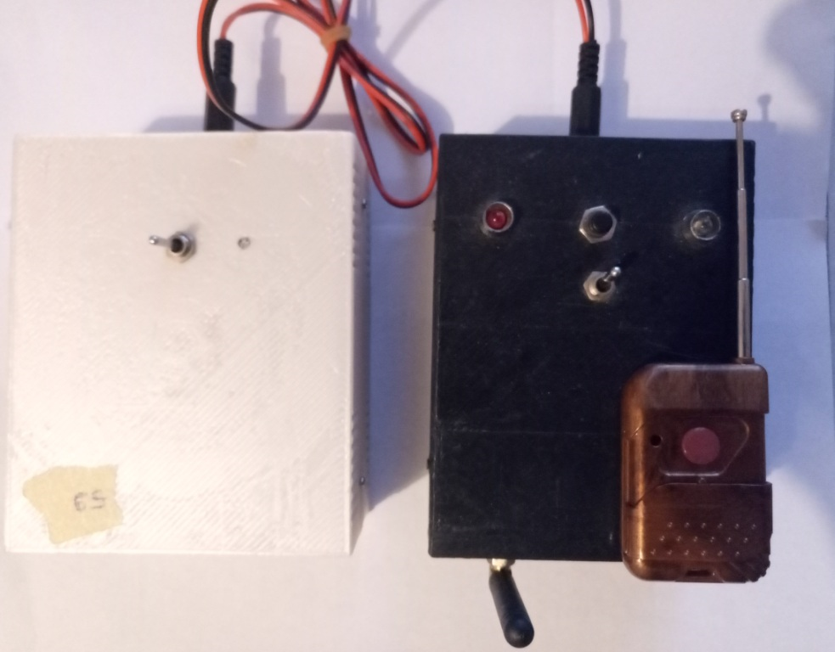

Use a jack to make sure that the polarity is correct when connecting them.

# Step 12 – Record some thrust curve.

Plug the test stand board to the gauge sensor. The sensor will be tarred when the board is powered on so make sure that you put your motor before you switch the test stand one.

Then connect the test stand to your launch controller and turn everything on. Depending of the type of motor you are using you will have to set your recording time. Do not do less than 5 seconds.

Fire your motor. This will trigger the recording of the thrust.

# Step 13 – Manage thrust Curves

You need ne to click on retrieve thrust curves to view your thrust curves. You then click on the thrust curve to display it. By sliding to the right you will be able to display the motor spec and export the curves.

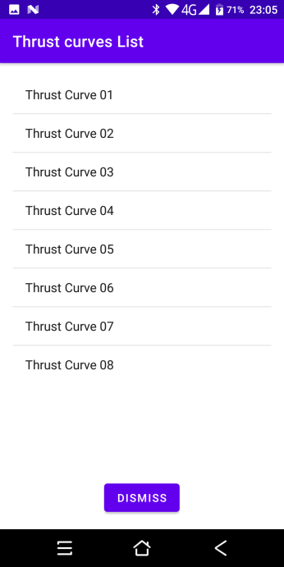 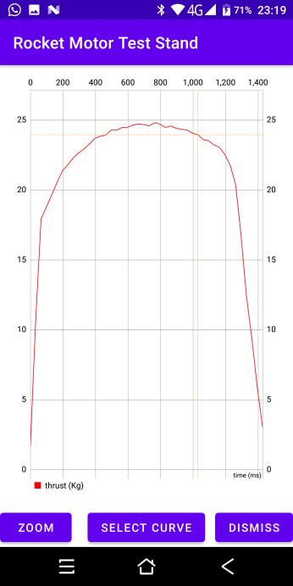 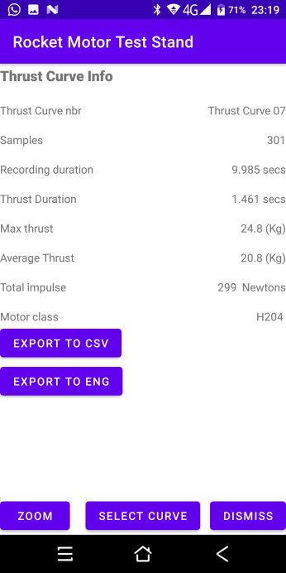

You can delete the last curve or all of them by going to the [RESET SETTINGS] section.

Note that the eeprom can store a maximum of 25 flights.

# Step 14 – Export and use thrust Curves

Each thrust curve can be exported as a CSV file so that you can plot it in Excel or can be exported as a RAST file so that you can use it with OpenRocket or Rocksim.

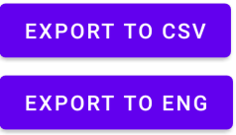

The files will be exported under the download directory.

Note that when exporting to RASP you will need to edit the file to enter the motor diameter, propellant and casing weight and casing length.

# Step 15 - Using the telemetry

If you want to have real time data you will need to use a 3DR telemetry module which is widely available and used by the drone community. You will need to replace the Bluetooth module with the 3DR module and configure the application so that it used USB rather than Bluetooth. Then click on the telemetry button from the main menu.



# Step 16 - Board status

If at any time you want to check that the sensor is properly calibrated or the memory using or the battery then you need to go to the status menu.

